FRANCIS XAVIER ENGINEERING COLLEGE

DEPARTMENT OF INFORMATION TECHNOLOGY

QUIZ GAME

PROJECT GUIDE:Mrs.SUBBU LAKSHMI BATCH:2nd YEAR

TEAM MEMBER:R.KAVITHA

M.SANKARI

MERLIN AHIJAH G.MOHAN

R.MUTHU LAKSHMI

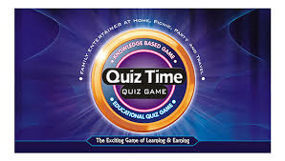

AIM:

This project aims at developing a application in C for Quiz Game.

This system allows the user to

1.Login

2.Set the Questions

3.Set the timer

4.Set the options for answer the questions

4.Display the score at the end of the game

STEPS :

1. Enter the login ID.

2. Set the rules

3. Press U key to start the



4. Select the options for the above question

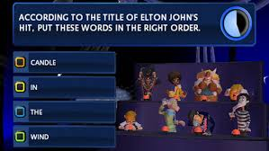

5. If the answers are selected at the particular time then submit the answers



6. Then the score will display

7. If the time is over then display game over and also display the scores



8. Press ENTER key to continue the game otherwise EXIT the game.





C program to playing the quiz: